**Program the System**

Step 1: Connect to Raspberry Pi

1. Open a terminal on your computer
2. SSH into your Raspberry Pi:

ssh <username>@stockticker.local

Replace <username> with the username you set during System Software Setup

Note: Instead of a terminal from your computer, you may use PuTTY software, which is widely used and available for free download. I originally used the Windows terminal but later switched to PuTTY.

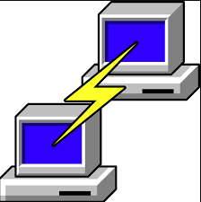

As I write this, PuTTY is available for download from here: https://www.chiark.greenend.org.uk/~sgtatham/putty/latest.html

If you decide to use PuTTY, here is how the initial window looks like:

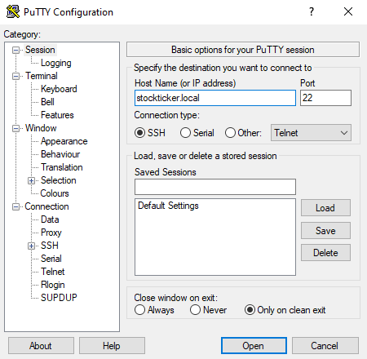

## Step 2: Update and Install Dependencies

Run the following commands:

sudo apt update

sudo apt upgrade -y

sudo apt install python3-pip -y

pip3 install yfinance pygame

Step 3: Create the Stock Ticker Script

1. You may use the inbuilt default editor “nano” to create the program, or else you may use another editor. Here we will use nano.

nano stock_ticker.py

1. Download, Copy and paste the code stock_ticker.py
2. Save and exit the file (Ctrl+X, then Y, then Enter)

Step 4: Execute

Run the following command:

python nano stock_ticker.py

If you followed all instructions correctly, you should be able to see the Stock tickers scrolling on the screen. Congratulations! You can now modify the python program according to your liking.

If after running the above program you get errors, don’t fret. As it is said “the road to success is paved with failures,” it took me at least twenty-five iterations of updates and modifications to make it to work. Depending on your setup, you may find that you need to update your Python program, install additional python modules. Please follow the warning / errors and you may need to do online search to understand the reasons and fix.